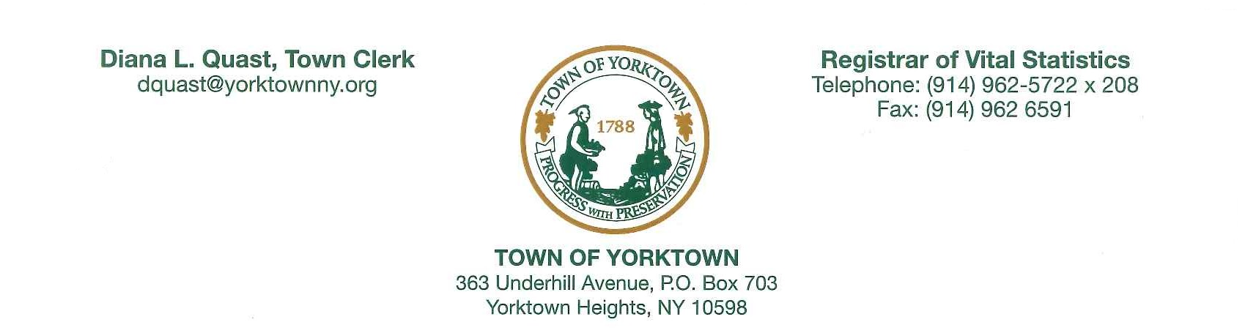

PUBLIC NOTICE
SPECIAL MEETING

The Town Board of the Town of Yorktown will hold a Special Meeting on Friday, January 6, 2017 at 3:00 P.M. at the Town Hall, 363 Underhill Avenue, Yorktown Heights, New York 10598.

DIANA L. QUAST, RMC
Town Clerk
Town of Yorktown

